

Cal Poly

California Polytechnic State University, San Luis Obispo, CA 93407

Date: April 7, 2009
To: Sherrie Amido
Fr: Cal Poly PASS Task Force
Re: PASS Website Analysis



In Brief
- PASS makes the task of planning a
schedule for students much more
tedious and difficult than it needs to
be

- Comparing schedules with the
current PASS can be as difficult as
having to write each schedule
down. The updated version would
allow side-by-side schedule viewing.

- In the updated version of PASS,
classes would no longer be listed as
“open” near the end of enrollment
when they are actually “closed.”
This would be achieved by
combining PASS and CPReg.

- Combining PASS and CPReg would
also allow for direct enrollment
without having to copy information
from one site to the next.

- A flow chart will be provided for
the student based on his major. He
will also have an option to auto-fill
a schedule with his required classes
based on the flow chart.


Students Using the PASS Website

Ask yourself: PASS or fail? Based on the complaints of most students at Cal Poly, it seems the consensus is “fail.” Once every ten to twelve weeks, Cal Poly students are required to plan a new schedule for the upcoming quarter. All Cal Poly students have to use PASS. Many students have had problems with it, whether it was trying to switch between two different schedules to compare them, having to transfer information from PASS to CPREG to register, or timing out just before you save your schedule. We believe that PASS is a very useful tool but there are still many flaws in the website. This report will explore and examine these flaws, and also propose ways to fix them in order to make PASS a more accessible, comprehensive, and easy to use website. By doing so students will be able to complete their schedules more quickly, and in some cases our proposals may even help students to enroll in classes they would have otherwise missed.

Time Taken to Create a Schedule

It takes an average student 4 minutes to get
to the completed schedule to save on pass,
and normally students will have 5-20
schedules to choose from, 4 minutes is just to
check one. The number of clicks to get to a
single schedule with 4 classes and availability
selected and saved is 32 With the proposed
improvements listed below, the number of
clicks is reduced to 16 and the time spent is
reduced to 2 minutes and 30 seconds.

Figure 1: The PASS website, selecting your availability
Source: http://pass.calpoly.edu/ 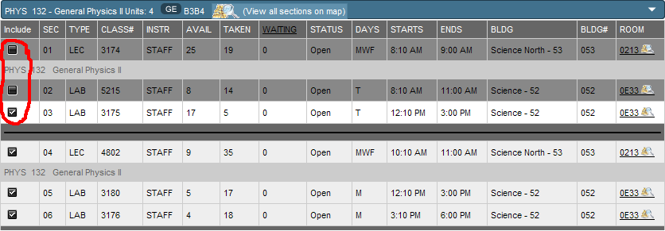

Availability

When you set your availability on PASS it will uncheck and gray out the classes that don’t fit within your time frame, on the next page (figure 1). However, it does not uncheck classes that are in your availability time frame but have required labs or lectures associated with a class that aren’t in your time frame. PASS will not let you continue until you manually find and uncheck all of the associated courses. With better coding, the site should not include classes with lectures or labs that aren’t within your availability.

The site should give an option to uncheck all classes and uncheck all full classes.

Also, to add to the site the availability should be moved to the second page with
the list of classes the student has selected. By doing this the student don’t have to
navigate away from the list of classes and lose their current selection if they wish to change their availability.

Schedule Format

The Select Schedule Section, page 3 on PASS (figure 2), should allow students to view their schedules in different ways. Right now it is just a vertical list format. By allowing students to view multiple schedules at once, they can compare a select group of schedules and save them individually if the choose to.

One other viewing option could be a grid view, where the schedule time previews that are currently on the right side of the page, would be arranged in a grid format as if they were files on a computer with the window set to “view as grid.” This would make it much easier to choose schedules based on the class time and when coupled together with the ability to view multiple schedules at once on page 4, it would greatly improve the schedule choosing experience.

Right now you have to select each schedule individually to see what teachers are teaching. With a new layout students could first select schedules by time in a grid view.

Figure 2: Grid Schedules
Source: http://pass.calpoly.edu
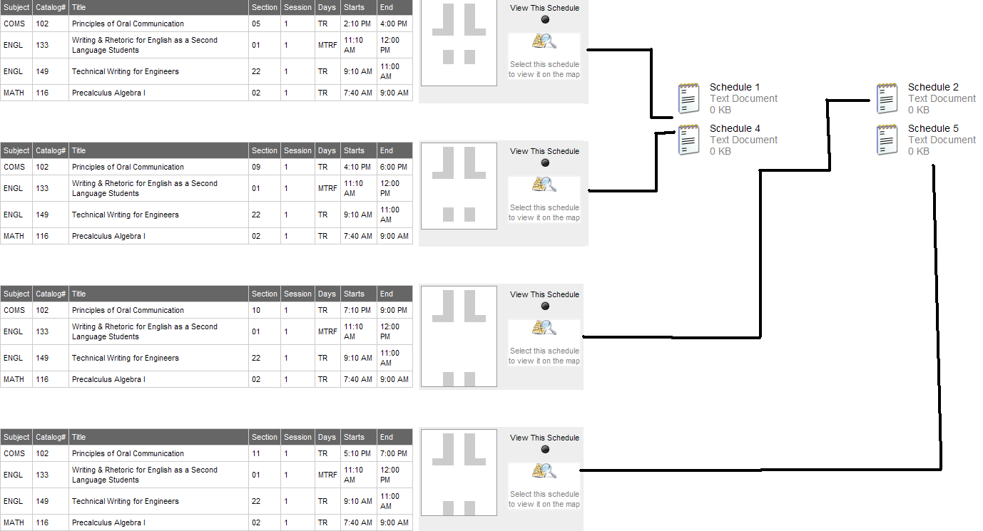

Schedule Format Continued

Then they could view the schedules they selected in a more informational view that is similar to page 3 on PASS now but with their teacher’s names added. This turns a multiple step process into just two easy selections.

Flowchart

Students should have access to their major’s flowchart (figure 3). Also, PASS should allow an auto-fill feature based on the students major, that major's flow chart, and the classes the student has already completed. This would be a feature in step 1 in the current PASS, so you could auto-fill the recommended courses then add or remove classes depending on what you want to take.
Web Design Flaws
To improve the format of the PASS website, adding more colors would be
more pleasing to the eye. The layout could also be improved, because it is hard to view on a smaller screen. The website should scale to make it easier to read.

The second page of PASS should contain a list of all possible classes, and this will reduce the height of the second page. To make PASS easier to view classes should be color coded according to closed and open classes, so that closed classes are highlighted in red and open classes in green. Color coding PASS will help
students pick classes that aren’t closed quicker.

Figure 3: Addition to PASS, Flowcharts by Major
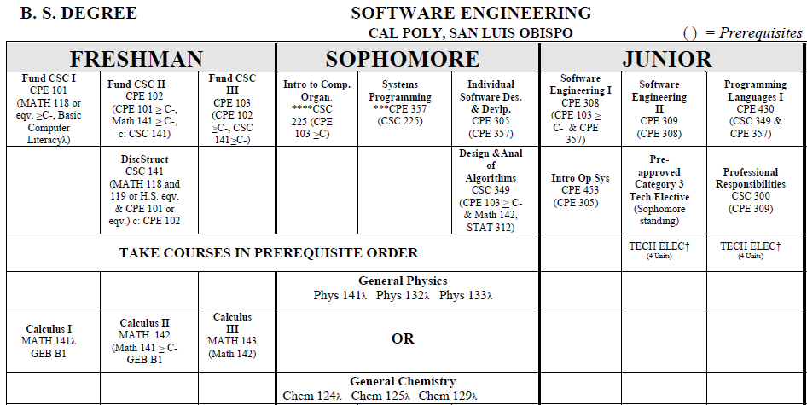
Source: http://eadvise.calpoly.edu/policy/forms/se_flow0709.pdf

Proposal Outcomes

We wish to create a more accessible PASS with easier side-by-side schedule viewing and more up-to-date and accurate list of course instructors. Viewing your different schedule options should be easier, through our “grid-viewing” option. Additionally we will strive to combine PASS and CPREG to allow fewer hassles and greatly increase efficiency. Our services will include access to the various major's
flowcharts with the option to auto-fill
from required classes, user selected
availability, and course offerings. This
allows us to turn a once arduous process
into a just few simple click

Johnson-Sheehan, Richard. Technical Communication Today. 3rd ed. Longman, 2009, 365-3

